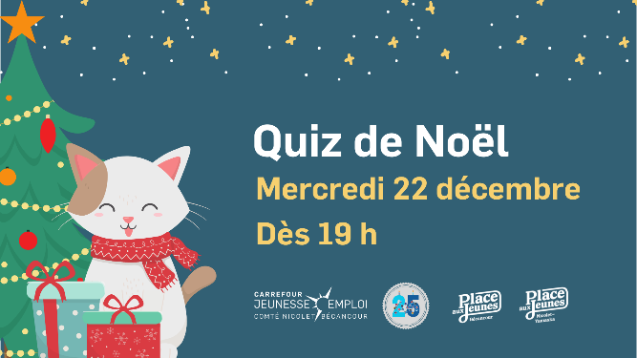

Feuille réponse - Quiz de Noël

Question 1. _________________________________________________________

Question 2. _________________________________________________________

Question 3. _________________________________________________________

Question 4. _________________________________________________________

Question 5. _________________________________________________________

Question 6. _________________________________________________________

Question 7. _________________________________________________________

Question 8.
- A ____________________________

- I _____________________________

- R _____________________________

Question 9. _________________________________________________________

Question 10. ________________________________________________________

Question 11. ________________________________________________________

Question 12. ________________________________________________________

Question 13. ________________________________________________________

Question 14. ________________________________________________________

Question 15. A. 3 décembre B. 11 décembre C. 23 décembre

Question 16. Vrai Faux

Question 17. ________________________________________________________

Question 18. ________________________________________________________

Question 19. ________________________________________________________

Question 20. ________________________________________________________

Question 21. A. 17 000 B. 21 000 C. 26 000

Question 22. ________________________________________________________

Question 23. ________________________________________________________

Question 24. Vrai Faux

Question 25. ________________________________________________________

TIRAGES !!!

MERCI DE VOTRE PARTICIPATION !
JOYEUSES FÊTES !

